RMarkdown DSC 520 - Project

Pushkar Chougule

Nov 20th 2020

## R Markdown

library(ggplot2)

**initial reading of California Housing prices csv**

## 'data.frame': 20640 obs. of 10 variables:  
## $ longitude : num -122 -122 -122 -122 -122 ...  
## $ latitude : num 37.9 37.9 37.9 37.9 37.9 ...  
## $ housing_median_age: num 41 21 52 52 52 52 52 52 42 52 ...  
## $ total_rooms : num 880 7099 1467 1274 1627 ...  
## $ total_bedrooms : num 129 1106 190 235 280 ...  
## $ population : num 322 2401 496 558 565 ...  
## $ households : num 126 1138 177 219 259 ...  
## $ median_income : num 8.33 8.3 7.26 5.64 3.85 ...  
## $ median_house_value: num 452600 358500 352100 341300 342200 ...  
## $ ocean_proximity : Factor w/ 5 levels "<1H OCEAN","INLAND",..: 4 4 4 4 4 4 4 4 4 4 ...

**histograms and scatter plots for initial analysis**

California Housing prices dataset has 10 columns including median house value and population, ocean proximity etc. there was not much significance and data was almost equally distributed. Thus not enough variables available for analysis. Also, when looked at the plots between. The total number of rooms, bedrooms data is not in standard format and would skew other dataset info, if merged with it. Hence decided not to use this dataset.

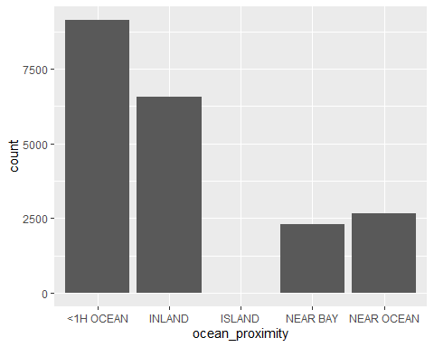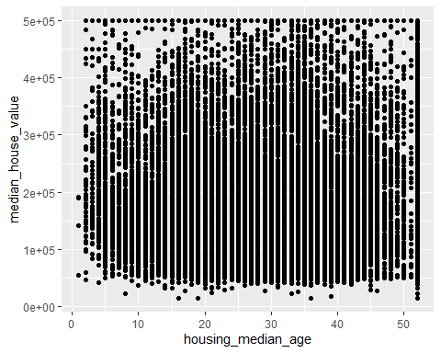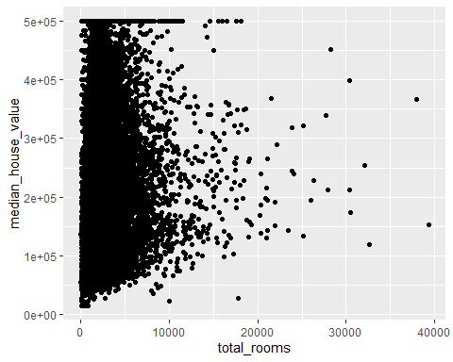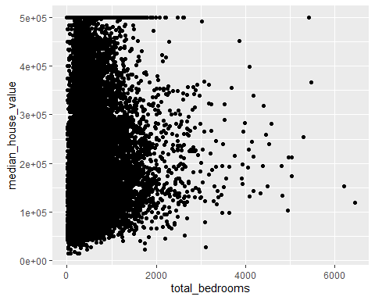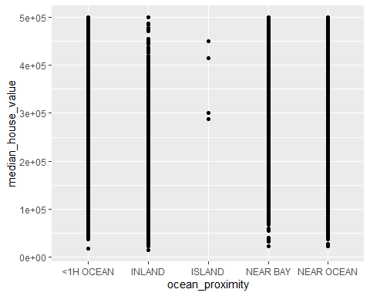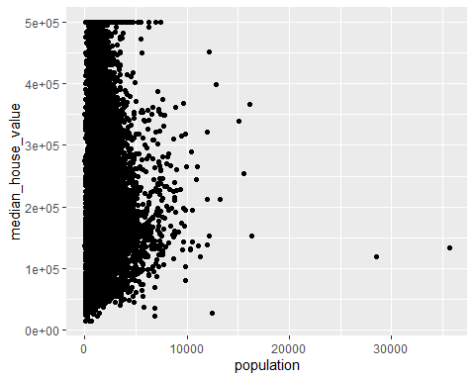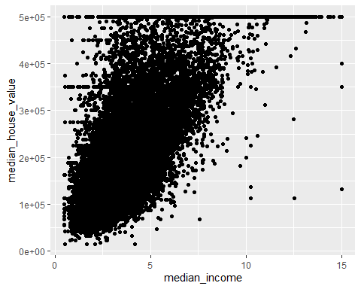

1. There are 5 distinct categories in the ocean proximity variables
2. Housing median age vs. median house value scatter plot
3. scatter plot for total rooms vs. median house value
4. scatter plot for total bedrooms vs. median house value
5. Median House value price ranges are similar in each of the ocean proximity category, looking at the scatter plot
6. scatter plot for population vs median house value
7. median income vs median house value

**initial reading of London Housing prices csv**

## 'data.frame': 3480 obs. of 6 variables:  
## $ Price : int 1675000 650000 735000 1765000 675000 420000 1475000 650000 2500000 925000 ...  
## $ House_Type : Factor w/ 8 levels "Bungalow","Duplex",..: 4 3 3 4 3 3 4 6 4 3 ...  
## $ Area_sqft : int 2716 814 761 1986 700 403 1548 560 1308 646 ...  
## $ Num_Bedrooms : int 5 2 2 4 2 1 4 1 3 2 ...  
## $ Num_Bathrooms : int 5 2 2 4 2 1 4 1 3 2 ...  
## $ Num_Receptions: int 5 2 2 4 2 1 4 1 3 2 ...

**London housing data initial analysis histogram**

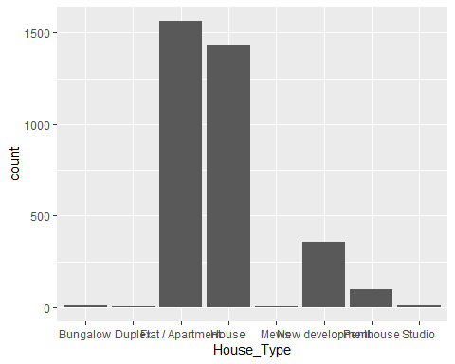

**initial reading of US Housing prices csv file and summary**

## MSSubClass MSZoning LotFrontage LotArea BldgType   
## 20 :536 C (all): 10 Min. : 0.00 Min. : 1300 1Fam :1220   
## 60 :299 FV : 65 1st Qu.: 42.00 1st Qu.: 7554 2fmCon: 31   
## 50 :144 RH : 16 Median : 63.00 Median : 9478 Duplex: 52   
## 120 : 87 RL :1151 Mean : 57.62 Mean : 10517 Twnhs : 43   
## 30 : 69 RM : 218 3rd Qu.: 79.00 3rd Qu.: 11602 TwnhsE: 114   
## 160 : 63 Max. :313.00 Max. :215245   
## (Other):262   
## HouseStyle LotConfig Neighborhood Condition1   
## 1Story :726 Length:1460 Length:1460 Length:1460   
## 2Story :445 Class :character Class :character Class :character   
## 1.5Fin :154 Mode :character Mode :character Mode :character   
## SLvl : 65   
## SFoyer : 37   
## 1.5Unf : 14   
## (Other): 19   
## Condition2 Foundation RoofStyle RoofMatl   
## Length:1460 Length:1460 Length:1460 Length:1460   
## Class :character Class :character Class :character Class :character   
## Mode :character Mode :character Mode :character Mode :character   
##   
##   
##   
##   
## Exterior1st Exterior2nd ExterQual HeatingQC   
## Length:1460 Length:1460 Length:1460 Length:1460   
## Class :character Class :character Class :character Class :character   
## Mode :character Mode :character Mode :character Mode :character   
##   
##   
##   
##   
## Electrical OverallQual OverallCond YearBuilt YearRemodAdd   
## Length:1460 5 :397 5 :821 Min. :1872 Min. :1950   
## Class :character 6 :374 6 :252 1st Qu.:1954 1st Qu.:1967   
## Mode :character 7 :319 7 :205 Median :1973 Median :1994   
## 8 :168 8 : 72 Mean :1971 Mean :1985   
## 4 :116 4 : 57 3rd Qu.:2000 3rd Qu.:2004   
## 9 : 43 3 : 25 Max. :2010 Max. :2010   
## (Other): 43 (Other): 28   
## MasVnrArea MasVnrType WoodDeckSF OpenPorchSF   
## Min. : 0.0 BrkCmn : 15 Min. : 0.00 Min. : 0.00   
## 1st Qu.: 0.0 BrkFace:445 1st Qu.: 0.00 1st Qu.: 0.00   
## Median : 0.0 None :864 Median : 0.00 Median : 25.00   
## Mean : 103.7 Stone :128 Mean : 94.24 Mean : 46.66   
## 3rd Qu.: 166.0 Unk : 8 3rd Qu.:168.00 3rd Qu.: 68.00   
## Max. :1600.0 Max. :857.00 Max. :547.00   
## NA's :8   
## EnclosedPorch BsmtFinSF1 TotalBsmtSF BsmtFinType1   
## Min. : 0.00 Min. : 0.0 Min. : 0.0 Length:1460   
## 1st Qu.: 0.00 1st Qu.: 0.0 1st Qu.: 795.8 Class :character   
## Median : 0.00 Median : 383.5 Median : 991.5 Mode :character   
## Mean : 21.95 Mean : 443.6 Mean :1057.4   
## 3rd Qu.: 0.00 3rd Qu.: 712.2 3rd Qu.:1298.2   
## Max. :552.00 Max. :5644.0 Max. :6110.0   
##   
## BsmtQual GrLivArea FullBath HalfBath   
## Length:1460 Min. : 334 Min. :0.000 Min. :0.0000   
## Class :character 1st Qu.:1130 1st Qu.:1.000 1st Qu.:0.0000   
## Mode :character Median :1464 Median :2.000 Median :0.0000   
## Mean :1515 Mean :1.565 Mean :0.3829   
## 3rd Qu.:1777 3rd Qu.:2.000 3rd Qu.:1.0000   
## Max. :5642 Max. :3.000 Max. :2.0000   
##   
## BedroomAbvGr TotRmsAbvGrd GarageArea Fence   
## Min. :0.000 Min. : 2.000 Min. : 0.0 GdPrv: 59   
## 1st Qu.:2.000 1st Qu.: 5.000 1st Qu.: 334.5 GdWo : 54   
## Median :3.000 Median : 6.000 Median : 480.0 MnPrv: 157   
## Mean :2.866 Mean : 6.518 Mean : 473.0 MnWw : 11   
## 3rd Qu.:3.000 3rd Qu.: 7.000 3rd Qu.: 576.0 NA's :1179   
## Max. :8.000 Max. :14.000 Max. :1418.0   
##   
## SalePrice   
## Min. : 34900   
## 1st Qu.:129975   
## Median :163000   
## Mean :180921   
## 3rd Qu.:214000   
## Max. :755000   
##

US Housing prices dataset has plenty of variables (81 in all) and hence I will be using this dataset for my analysis purpose. I have manually looked at the data variables and also used some of the plots to understand the data points / variables. I have tried to capture this information below. Noticed that TotalBsmtSF is the addition of BsmtFinSF1, BsmtFinSF2 and BsmtUnfSF. Similarly 1stFlrSF and 2ndFlrSF columns values are combined into and it is present in variable GrLivArea.

**histogram plots for initial analysis of data to also help with data cleanup steps**

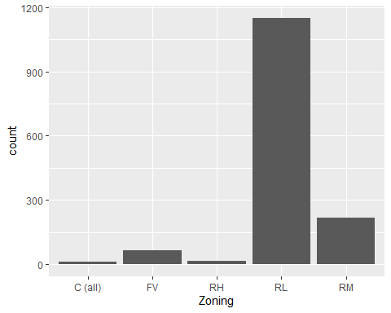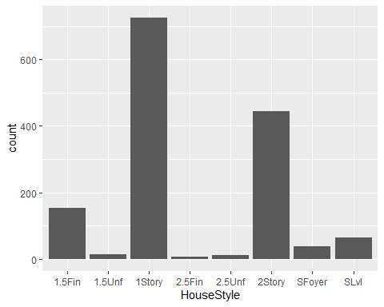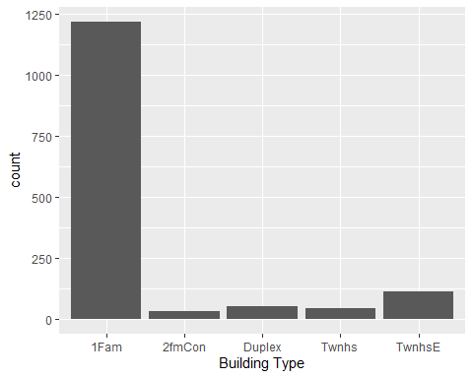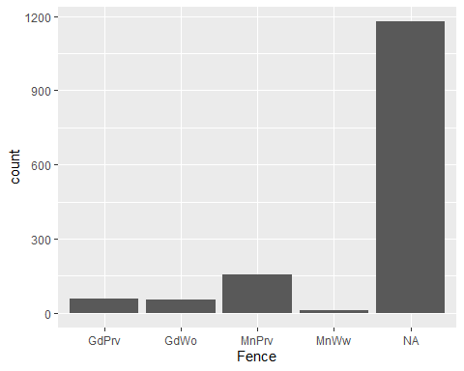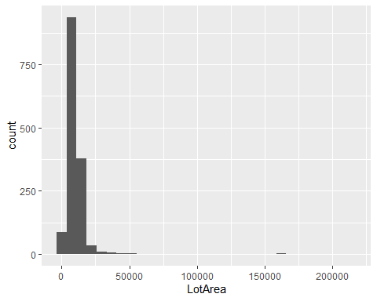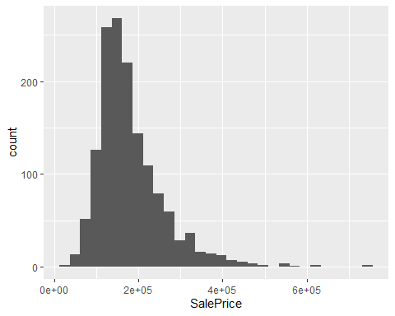

**box plots and scatter plots for initial analysis of data to also help with data cleanup steps**

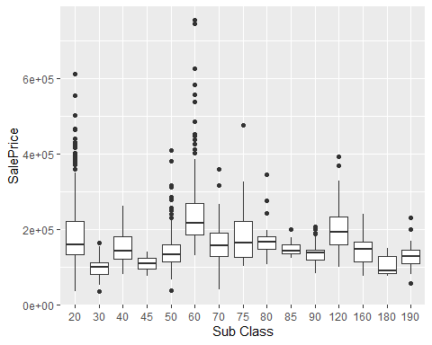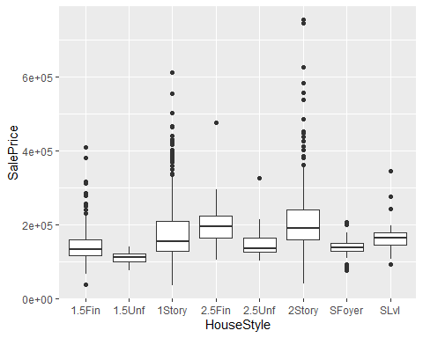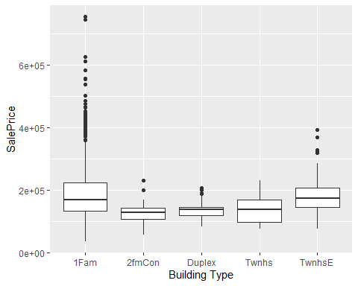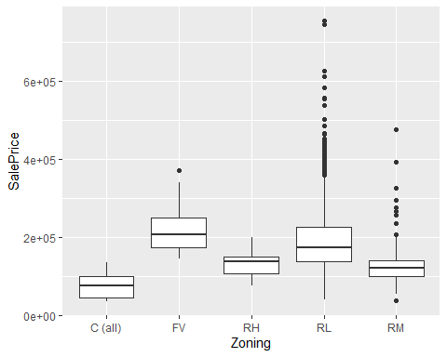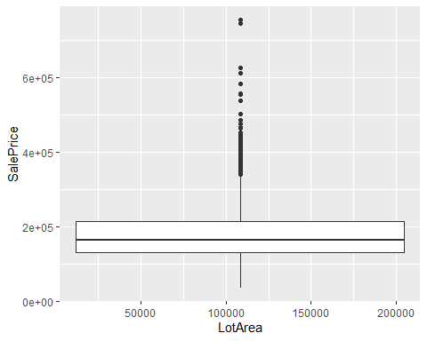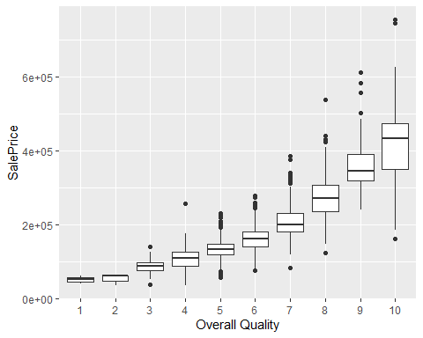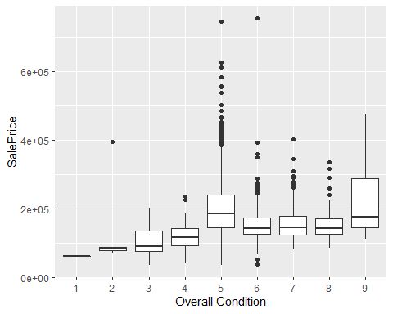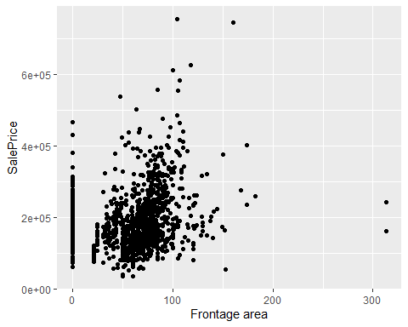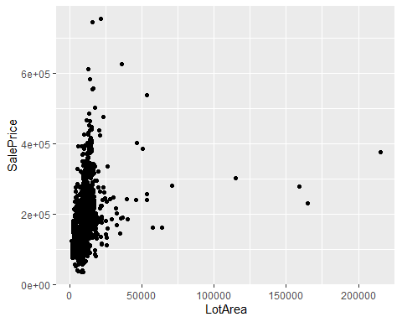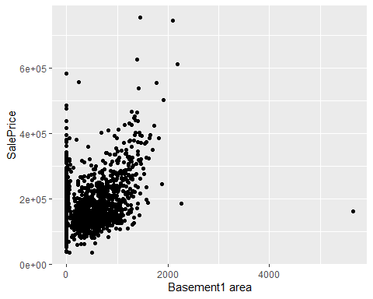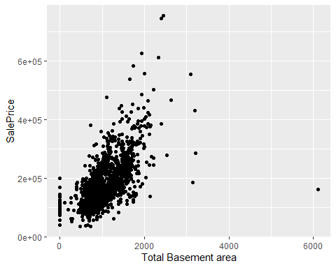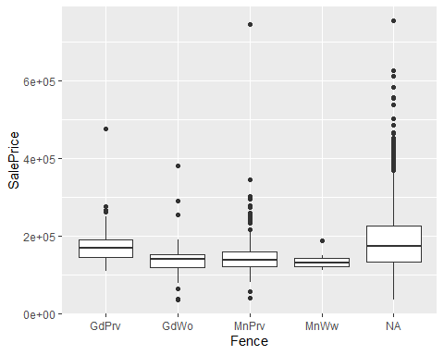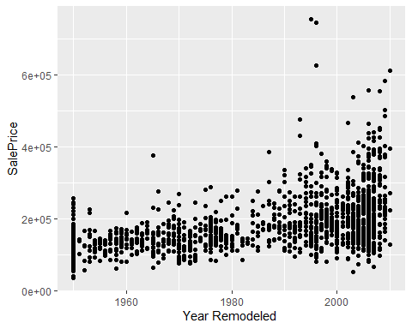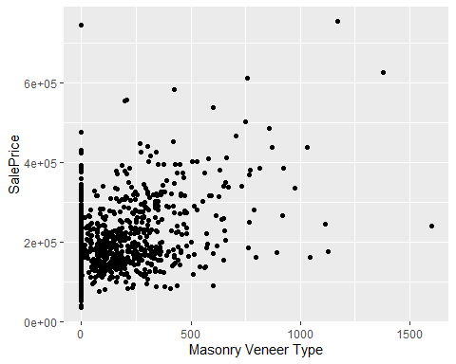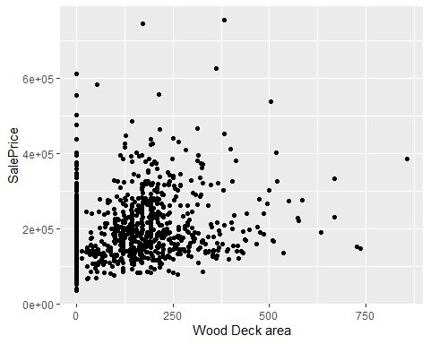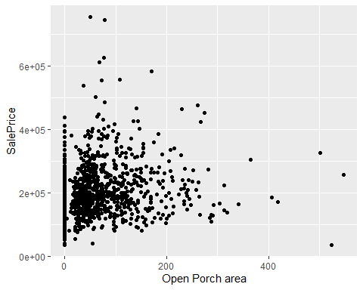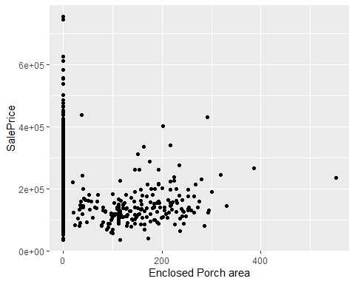

**data cleanup / delete outliers and create data subset and summary() of the same subset**

the variables selected in the current subset dataframe have been arrived at after multiple iterations of the model and fine tuning to add / drop variables from the subset to achieve better accuracy.

## 'data.frame': 1344 obs. of 39 variables:  
## $ MSSubClass : Factor w/ 15 levels "20","30","40",..: 6 1 6 7 6 5 1 6 5 15 ...  
## $ MSZoning : Factor w/ 5 levels "C (all)","FV",..: 4 4 4 4 4 4 4 4 5 4 ...  
## $ BldgType : Factor w/ 5 levels "1Fam","2fmCon",..: 1 1 1 1 1 1 1 1 1 2 ...  
## $ HouseStyle : Factor w/ 8 levels "1.5Fin","1.5Unf",..: 6 3 6 6 6 1 3 6 1 2 ...  
## $ LotConfig : chr "Inside" "FR2" "Inside" "Corner" ...  
## $ Neighborhood : chr "CollgCr" "Veenker" "CollgCr" "Crawfor" ...  
## $ Condition1 : chr "Norm" "Feedr" "Norm" "Norm" ...  
## $ Condition2 : chr "Norm" "Norm" "Norm" "Norm" ...  
## $ Foundation : chr "PConc" "CBlock" "PConc" "BrkTil" ...  
## $ RoofStyle : chr "Gable" "Gable" "Gable" "Gable" ...  
## $ RoofMatl : chr "CompShg" "CompShg" "CompShg" "CompShg" ...  
## $ Exterior1st : chr "VinylSd" "MetalSd" "VinylSd" "Wd Sdng" ...  
## $ Exterior2nd : chr "VinylSd" "MetalSd" "VinylSd" "Wd Shng" ...  
## $ ExterQual : chr "Gd" "TA" "Gd" "TA" ...  
## $ HeatingQC : chr "Ex" "Ex" "Ex" "Gd" ...  
## $ Electrical : chr "SBrkr" "SBrkr" "SBrkr" "SBrkr" ...  
## $ LotFrontage : num 65 80 68 60 84 85 75 0 51 50 ...  
## $ LotArea : int 8450 9600 11250 9550 14260 14115 10084 10382 6120 7420 ...  
## $ OverallQual : Factor w/ 10 levels "1","2","3","4",..: 7 6 7 7 8 5 8 7 7 5 ...  
## $ OverallCond : Factor w/ 9 levels "1","2","3","4",..: 5 8 5 5 5 5 5 6 5 6 ...  
## $ YearBuilt : int 2003 1976 2001 1915 2000 1993 2004 1973 1931 1939 ...  
## $ YearRemodAdd : int 2003 1976 2002 1970 2000 1995 2005 1973 1950 1950 ...  
## $ MasVnrArea : int 196 0 162 0 350 0 186 240 0 0 ...  
## $ MasVnrType : Factor w/ 5 levels "BrkCmn","BrkFace",..: 2 3 2 3 2 3 4 4 3 3 ...  
## $ WoodDeckSF : int 0 298 0 0 192 40 255 235 90 0 ...  
## $ OpenPorchSF : int 61 0 42 35 84 30 57 204 0 4 ...  
## $ EnclosedPorch: int 0 0 0 272 0 0 0 228 205 0 ...  
## $ BsmtFinSF1 : int 706 978 486 216 655 732 1369 859 0 851 ...  
## $ TotalBsmtSF : int 856 1262 920 756 1145 796 1686 1107 952 991 ...  
## $ BsmtFinType1 : chr "GLQ" "ALQ" "GLQ" "ALQ" ...  
## $ BsmtQual : chr "Gd" "Gd" "Gd" "TA" ...  
## $ GrLivArea : int 1710 1262 1786 1717 2198 1362 1694 2090 1774 1077 ...  
## $ FullBath : int 2 2 2 1 2 1 2 2 2 1 ...  
## $ HalfBath : int 1 0 1 0 1 1 0 1 0 0 ...  
## $ TotBaths : num 2.5 2 2.5 1 2.5 1.5 2 2.5 2 1 ...  
## $ BedroomAbvGr : int 3 3 3 3 4 1 3 3 2 2 ...  
## $ TotRmsAbvGrd : int 8 6 6 7 9 5 7 7 8 5 ...  
## $ GarageArea : int 548 460 608 642 836 480 636 484 468 205 ...  
## $ SalePrice : int 208500 181500 223500 140000 250000 143000 307000 200000 129900 118000 ...

## MSSubClass MSZoning BldgType HouseStyle LotConfig   
## 20 :487 C (all): 9 1Fam :1111 1Story :669 Length:1344   
## 60 :260 FV : 64 2fmCon: 28 2Story :401 Class :character   
## 50 :137 RH : 16 Duplex: 50 1.5Fin :145 Mode :character   
## 120 : 85 RL :1040 Twnhs : 43 SLvl : 61   
## 30 : 67 RM : 215 TwnhsE: 112 SFoyer : 37   
## 160 : 63 1.5Unf : 14   
## (Other):245 (Other): 17   
## Neighborhood Condition1 Condition2 Foundation   
## Length:1344 Length:1344 Length:1344 Length:1344   
## Class :character Class :character Class :character Class :character   
## Mode :character Mode :character Mode :character Mode :character   
##   
##   
##   
##   
## RoofStyle RoofMatl Exterior1st Exterior2nd   
## Length:1344 Length:1344 Length:1344 Length:1344   
## Class :character Class :character Class :character Class :character   
## Mode :character Mode :character Mode :character Mode :character   
##   
##   
##   
##   
## ExterQual HeatingQC Electrical LotFrontage   
## Length:1344 Length:1344 Length:1344 Min. : 0.00   
## Class :character Class :character Class :character 1st Qu.: 42.00   
## Mode :character Mode :character Mode :character Median : 61.00   
## Mean : 56.19   
## 3rd Qu.: 77.00   
## Max. :182.00   
##   
## LotArea OverallQual OverallCond YearBuilt YearRemodAdd   
## Min. : 1300 5 :380 5 :742 Min. :1872 Min. :1950   
## 1st Qu.: 7310 6 :359 6 :240 1st Qu.:1953 1st Qu.:1966   
## Median : 9164 7 :301 7 :194 Median :1972 Median :1992   
## Mean : 9148 8 :145 8 : 70 Mean :1970 Mean :1984   
## 3rd Qu.:11042 4 :112 4 : 51 3rd Qu.:2000 3rd Qu.:2003   
## Max. :17920 9 : 20 3 : 24 Max. :2009 Max. :2010   
## (Other): 27 (Other): 23   
## MasVnrArea MasVnrType WoodDeckSF OpenPorchSF   
## Min. : 0.00 BrkCmn : 12 Min. : 0.0 Min. : 0.00   
## 1st Qu.: 0.00 BrkFace:407 1st Qu.: 0.0 1st Qu.: 0.00   
## Median : 0.00 None :819 Median : 0.0 Median : 22.00   
## Mean : 89.34 Stone :100 Mean : 86.9 Mean : 43.83   
## 3rd Qu.: 143.75 Unk : 6 3rd Qu.:160.0 3rd Qu.: 64.00   
## Max. :1600.00 Max. :736.0 Max. :547.00   
## NA's :6   
## EnclosedPorch BsmtFinSF1 TotalBsmtSF BsmtFinType1   
## Min. : 0.00 Min. : 0.0 Min. : 0.0 Length:1344   
## 1st Qu.: 0.00 1st Qu.: 0.0 1st Qu.: 783.0 Class :character   
## Median : 0.00 Median : 366.5 Median : 968.5 Mode :character   
## Mean : 21.86 Mean : 407.7 Mean :1012.8   
## 3rd Qu.: 0.00 3rd Qu.: 679.2 3rd Qu.:1237.8   
## Max. :386.00 Max. :1880.0 Max. :3206.0   
##   
## BsmtQual GrLivArea FullBath HalfBath   
## Length:1344 Min. : 334 Min. :0.000 Min. :0.0000   
## Class :character 1st Qu.:1113 1st Qu.:1.000 1st Qu.:0.0000   
## Mode :character Median :1426 Median :2.000 Median :0.0000   
## Mean :1454 Mean :1.532 Mean :0.3705   
## 3rd Qu.:1718 3rd Qu.:2.000 3rd Qu.:1.0000   
## Max. :3395 Max. :3.000 Max. :2.0000   
##   
## TotBaths BedroomAbvGr TotRmsAbvGrd GarageArea   
## Min. :0.000 Min. :0.000 Min. : 2.000 Min. : 0.0   
## 1st Qu.:1.000 1st Qu.:2.000 1st Qu.: 5.000 1st Qu.: 308.0   
## Median :2.000 Median :3.000 Median : 6.000 Median : 464.5   
## Mean :1.717 Mean :2.854 Mean : 6.381 Mean : 454.0   
## 3rd Qu.:2.000 3rd Qu.:3.000 3rd Qu.: 7.000 3rd Qu.: 572.0   
## Max. :3.500 Max. :8.000 Max. :14.000 Max. :1390.0   
##   
## SalePrice   
## Min. : 34900   
## 1st Qu.:128000   
## Median :157700   
## Mean :168855   
## 3rd Qu.:200625   
## Max. :340000   
##

**Scatter Plots for relationship between Sale Price and some of the predictor variables**

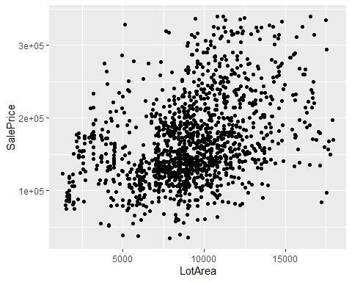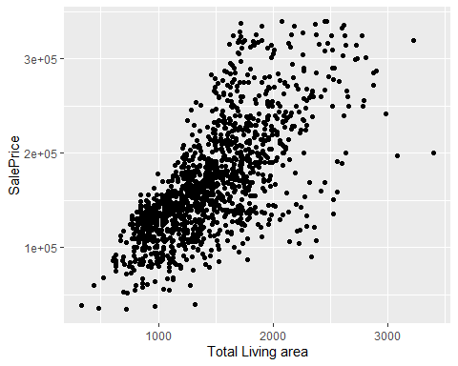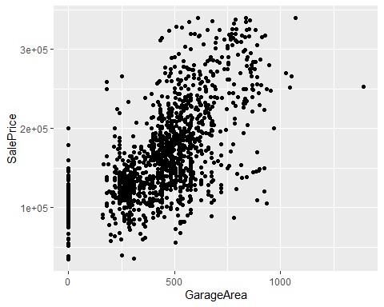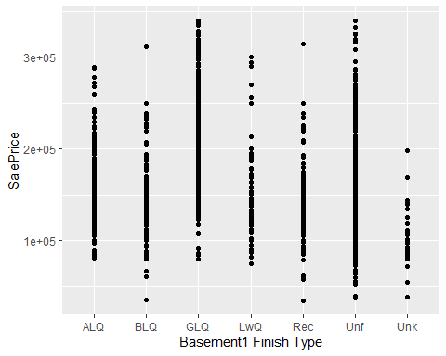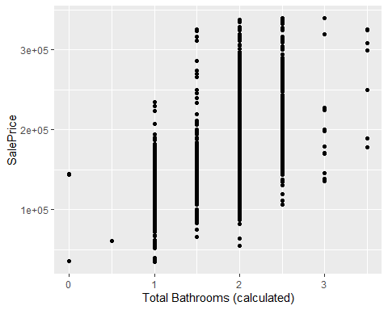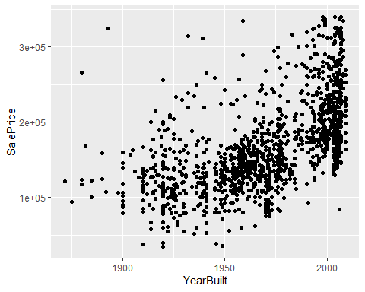

##head() from the modified subset data frame

## MSSubClass MSZoning BldgType HouseStyle LotConfig Neighborhood Condition1  
## 1 60 RL 1Fam 2Story Inside CollgCr Norm  
## 2 20 RL 1Fam 1Story FR2 Veenker Feedr  
## 3 60 RL 1Fam 2Story Inside CollgCr Norm  
## 4 70 RL 1Fam 2Story Corner Crawfor Norm  
## 5 60 RL 1Fam 2Story FR2 NoRidge Norm  
## 6 50 RL 1Fam 1.5Fin Inside Mitchel Norm  
## Condition2 Foundation RoofStyle RoofMatl Exterior1st Exterior2nd ExterQual  
## 1 Norm PConc Gable CompShg VinylSd VinylSd Gd  
## 2 Norm CBlock Gable CompShg MetalSd MetalSd TA  
## 3 Norm PConc Gable CompShg VinylSd VinylSd Gd  
## 4 Norm BrkTil Gable CompShg Wd Sdng Wd Shng TA  
## 5 Norm PConc Gable CompShg VinylSd VinylSd Gd  
## 6 Norm Wood Gable CompShg VinylSd VinylSd TA  
## HeatingQC Electrical LotFrontage LotArea OverallQual OverallCond YearBuilt  
## 1 Ex SBrkr 65 8450 7 5 2003  
## 2 Ex SBrkr 80 9600 6 8 1976  
## 3 Ex SBrkr 68 11250 7 5 2001  
## 4 Gd SBrkr 60 9550 7 5 1915  
## 5 Ex SBrkr 84 14260 8 5 2000  
## 6 Ex SBrkr 85 14115 5 5 1993  
## YearRemodAdd MasVnrArea MasVnrType WoodDeckSF OpenPorchSF EnclosedPorch  
## 1 2003 196 BrkFace 0 61 0  
## 2 1976 0 None 298 0 0  
## 3 2002 162 BrkFace 0 42 0  
## 4 1970 0 None 0 35 272  
## 5 2000 350 BrkFace 192 84 0  
## 6 1995 0 None 40 30 0  
## BsmtFinSF1 TotalBsmtSF BsmtFinType1 BsmtQual GrLivArea FullBath HalfBath  
## 1 706 856 GLQ Gd 1710 2 1  
## 2 978 1262 ALQ Gd 1262 2 0  
## 3 486 920 GLQ Gd 1786 2 1  
## 4 216 756 ALQ TA 1717 1 0  
## 5 655 1145 GLQ Gd 2198 2 1  
## 6 732 796 GLQ Gd 1362 1 1  
## TotBaths BedroomAbvGr TotRmsAbvGrd GarageArea SalePrice  
## 1 2.5 3 8 548 208500  
## 2 2.0 3 6 460 181500  
## 3 2.5 3 6 608 223500  
## 4 1.0 3 7 642 140000  
## 5 2.5 4 9 836 250000  
## 6 1.5 1 5 480 143000

**correlation - R2 for various numeric variables with Sale Price**

cor(housing_df$SalePrice, housing_df$LotArea)^2

## [1] 0.1528357

cor(housing_df$SalePrice, housing_df$YearBuilt)^2

## [1] 0.3497324

cor(housing_df$SalePrice, housing_df$YearRemodAdd)^2

## [1] 0.3085205

cor(housing_df$SalePrice, housing_df$GrLivArea)^2

## [1] 0.4813659

cor(housing_df$SalePrice, (housing_df$FullBath + (housing_df$HalfBath * 0.5)))^2

## [1] 0.390098

cor(housing_df$SalePrice, housing_df$BedroomAbvGr)^2

## [1] 0.0397595

cor(housing_df$SalePrice, housing_df$TotRmsAbvGrd)^2

## [1] 0.2298562

cor(housing_df$SalePrice, housing_df$GarageArea)^2

## [1] 0.4066953

cor(housing_df$SalePrice, housing_df$BsmtFinSF1)^2

## [1] 0.09712678

cor(housing_df$SalePrice, housing_df$TotalBsmtSF)^2

## [1] 0.3482836

cor(housing_df$SalePrice, housing_df$WoodDeckSF)^2

## [1] 0.08447678

cor(housing_df$SalePrice, housing_df$OpenPorchSF)^2

## [1] 0.1118559

cor(housing_df$SalePrice, housing_df$EnclosedPorch)^2

## [1] 0.02645305

##housing price prediction - multiple regression model creation and summary() of the models

housing_mod_lm1 <- lm(SalePrice ~ MSSubClass + MSZoning + BldgType + HouseStyle + LotConfig + Neighborhood + Condition1 + Condition2 + Foundation + RoofStyle + RoofMatl + Exterior1st + Exterior2nd + ExterQual + HeatingQC + Electrical + LotArea + LotFrontage + OverallQual + OverallCond + YearBuilt + YearRemodAdd + MasVnrArea + MasVnrType + WoodDeckSF + OpenPorchSF + GrLivArea + TotRmsAbvGrd + GarageArea + TotalBsmtSF + BsmtFinType1 + BsmtQual, data = housing_df)  
  
summary(housing_mod_lm1)

##   
## Call:  
## lm(formula = SalePrice ~ MSSubClass + MSZoning + BldgType + HouseStyle +   
## LotConfig + Neighborhood + Condition1 + Condition2 + Foundation +   
## RoofStyle + RoofMatl + Exterior1st + Exterior2nd + ExterQual +   
## HeatingQC + Electrical + LotArea + LotFrontage + OverallQual +   
## OverallCond + YearBuilt + YearRemodAdd + MasVnrArea + MasVnrType +   
## WoodDeckSF + OpenPorchSF + GrLivArea + TotRmsAbvGrd + GarageArea +   
## TotalBsmtSF + BsmtFinType1 + BsmtQual, data = housing_df)  
##   
## Residuals:  
## Min 1Q Median 3Q Max   
## -118601 -8412 303 8189 66304   
##   
## Coefficients: (3 not defined because of singularities)  
## Estimate Std. Error t value Pr(>|t|)   
## (Intercept) -1.074e+06 1.285e+05 -8.360 < 2e-16 ***  
## MSSubClass30 -2.182e+03 3.435e+03 -0.635 0.525404   
## MSSubClass40 -1.264e+03 1.042e+04 -0.121 0.903457   
## MSSubClass45 -8.177e+03 1.545e+04 -0.529 0.596701   
## MSSubClass50 -8.141e+02 6.316e+03 -0.129 0.897455   
## MSSubClass60 7.950e+03 5.431e+03 1.464 0.143517   
## MSSubClass70 3.307e+03 5.965e+03 0.554 0.579443   
## MSSubClass75 1.158e+04 1.215e+04 0.953 0.340742   
## MSSubClass80 -5.037e+03 8.002e+03 -0.629 0.529185   
## MSSubClass85 -5.102e+03 7.183e+03 -0.710 0.477611   
## MSSubClass90 -1.548e+04 3.767e+03 -4.109 4.24e-05 ***  
## MSSubClass120 8.925e+03 1.063e+04 0.839 0.401476   
## MSSubClass160 -1.741e+03 1.250e+04 -0.139 0.889235   
## MSSubClass180 7.083e+03 1.377e+04 0.514 0.607174   
## MSSubClass190 1.573e+03 1.914e+04 0.082 0.934495   
## MSZoningFV 4.370e+04 8.796e+03 4.968 7.76e-07 ***  
## MSZoningRH 3.176e+04 8.661e+03 3.667 0.000256 ***  
## MSZoningRL 3.587e+04 7.451e+03 4.814 1.67e-06 ***  
## MSZoningRM 2.954e+04 7.001e+03 4.219 2.64e-05 ***  
## BldgType2fmCon -4.141e+03 1.873e+04 -0.221 0.825083   
## BldgTypeDuplex NA NA NA NA   
## BldgTypeTwnhs -2.229e+04 1.120e+04 -1.990 0.046867 *   
## BldgTypeTwnhsE -1.484e+04 1.063e+04 -1.396 0.162965   
## HouseStyle1.5Unf 1.223e+04 1.551e+04 0.789 0.430519   
## HouseStyle1Story -1.188e+03 6.214e+03 -0.191 0.848416   
## HouseStyle2.5Fin -3.512e+04 1.198e+04 -2.931 0.003445 **   
## HouseStyle2.5Unf -7.632e+03 1.187e+04 -0.643 0.520466   
## HouseStyle2Story -3.372e+03 5.654e+03 -0.596 0.551007   
## HouseStyleSFoyer 5.751e+03 7.969e+03 0.722 0.470643   
## HouseStyleSLvl 5.186e+03 8.904e+03 0.582 0.560378   
## LotConfigCulDSac 7.917e+02 2.465e+03 0.321 0.748176   
## LotConfigFR2 -8.065e+03 2.978e+03 -2.708 0.006861 **   
## LotConfigFR3 -1.170e+04 9.119e+03 -1.283 0.199610   
## LotConfigInside -1.859e+03 1.291e+03 -1.440 0.150179   
## NeighborhoodBlueste 1.338e+04 1.379e+04 0.970 0.332237   
## NeighborhoodBrDale 1.114e+04 8.399e+03 1.326 0.185106   
## NeighborhoodBrkSide 3.657e+03 6.788e+03 0.539 0.590139   
## NeighborhoodClearCr -5.690e+03 7.310e+03 -0.778 0.436509   
## NeighborhoodCollgCr -9.723e+03 5.223e+03 -1.862 0.062892 .   
## NeighborhoodCrawfor 1.806e+04 6.239e+03 2.895 0.003867 **   
## NeighborhoodEdwards -1.435e+04 5.816e+03 -2.468 0.013743 *   
## NeighborhoodGilbert -9.188e+03 5.656e+03 -1.625 0.104531   
## NeighborhoodIDOTRR -3.127e+03 7.743e+03 -0.404 0.686385   
## NeighborhoodMeadowV -1.829e+04 8.843e+03 -2.068 0.038879 *   
## NeighborhoodMitchel -1.425e+04 5.965e+03 -2.389 0.017056 *   
## NeighborhoodNAmes -1.207e+04 5.631e+03 -2.143 0.032325 *   
## NeighborhoodNoRidge 7.852e+03 6.309e+03 1.244 0.213573   
## NeighborhoodNPkVill 1.400e+02 9.915e+03 0.014 0.988736   
## NeighborhoodNridgHt 7.587e+03 5.529e+03 1.372 0.170222   
## NeighborhoodNWAmes -1.558e+04 5.802e+03 -2.685 0.007356 **   
## NeighborhoodOldTown -1.091e+04 6.926e+03 -1.575 0.115560   
## NeighborhoodSawyer -9.117e+03 5.875e+03 -1.552 0.120999   
## NeighborhoodSawyerW -4.883e+03 5.614e+03 -0.870 0.384573   
## NeighborhoodSomerst -6.473e+02 6.698e+03 -0.097 0.923030   
## NeighborhoodStoneBr 9.892e+03 6.575e+03 1.504 0.132750   
## NeighborhoodSWISU -5.235e+03 6.960e+03 -0.752 0.452129   
## NeighborhoodTimber -4.288e+03 6.092e+03 -0.704 0.481692   
## NeighborhoodVeenker 1.580e+04 7.665e+03 2.062 0.039474 *   
## Condition1Feedr 3.094e+03 3.633e+03 0.852 0.394656   
## Condition1Norm 7.721e+03 3.013e+03 2.562 0.010516 *   
## Condition1PosA 1.839e+04 8.063e+03 2.280 0.022766 *   
## Condition1PosN 1.156e+04 5.470e+03 2.113 0.034798 *   
## Condition1RRAe -1.700e+04 6.439e+03 -2.640 0.008401 **   
## Condition1RRAn 1.835e+03 5.078e+03 0.361 0.717969   
## Condition1RRNe -1.249e+04 1.254e+04 -0.996 0.319438   
## Condition1RRNn 1.706e+04 8.976e+03 1.901 0.057574 .   
## Condition2Feedr 1.851e+04 1.730e+04 1.070 0.284693   
## Condition2Norm 2.203e+04 1.520e+04 1.449 0.147473   
## Condition2PosA 6.989e+04 2.696e+04 2.592 0.009652 **   
## Condition2RRAn 2.675e+03 2.345e+04 0.114 0.909201   
## Condition2RRNn 2.777e+04 1.982e+04 1.401 0.161523   
## FoundationCBlock 2.714e+03 2.303e+03 1.178 0.238892   
## FoundationPConc 4.484e+03 2.473e+03 1.814 0.070006 .   
## FoundationSlab 4.224e+03 6.750e+03 0.626 0.531607   
## FoundationStone 8.061e+03 7.688e+03 1.048 0.294636   
## FoundationWood -2.608e+04 1.018e+04 -2.563 0.010510 *   
## RoofStyleGable -2.115e+04 1.328e+04 -1.593 0.111450   
## RoofStyleGambrel -1.217e+04 1.442e+04 -0.844 0.398826   
## RoofStyleHip -2.007e+04 1.330e+04 -1.509 0.131667   
## RoofStyleMansard -8.138e+03 1.535e+04 -0.530 0.596171   
## RoofMatlRoll -6.628e+03 1.832e+04 -0.362 0.717632   
## RoofMatlTar&Grv -7.037e+03 1.317e+04 -0.534 0.593284   
## RoofMatlWdShake -1.910e+04 1.081e+04 -1.767 0.077432 .   
## RoofMatlWdShngl -7.532e+03 1.260e+04 -0.598 0.550108   
## Exterior1stAsphShn 5.020e+03 2.353e+04 0.213 0.831127   
## Exterior1stBrkComm -4.562e+04 1.991e+04 -2.292 0.022104 *   
## Exterior1stBrkFace 1.445e+04 9.014e+03 1.603 0.109135   
## Exterior1stCBlock -9.884e+03 1.924e+04 -0.514 0.607467   
## Exterior1stCemntBd -1.109e+04 1.923e+04 -0.577 0.564324   
## Exterior1stHdBoard -1.582e+03 9.190e+03 -0.172 0.863329   
## Exterior1stImStucc 1.744e+03 2.019e+04 0.086 0.931156   
## Exterior1stMetalSd 1.488e+03 1.041e+04 0.143 0.886297   
## Exterior1stPlywood 1.994e+03 9.030e+03 0.221 0.825265   
## Exterior1stStone 8.692e+03 1.691e+04 0.514 0.607257   
## Exterior1stStucco 5.291e+03 1.030e+04 0.514 0.607507   
## Exterior1stVinylSd -8.846e+03 9.423e+03 -0.939 0.348065   
## Exterior1stWd Sdng -5.538e+03 8.809e+03 -0.629 0.529667   
## Exterior1stWdShing 9.097e+02 9.432e+03 0.096 0.923184   
## Exterior2ndAsphShn -9.424e+03 1.575e+04 -0.598 0.549734   
## Exterior2ndBrk Cmn 1.689e+04 1.465e+04 1.153 0.249124   
## Exterior2ndBrkFace 2.858e+03 9.424e+03 0.303 0.761700   
## Exterior2ndCBlock NA NA NA NA   
## Exterior2ndCmentBd 2.171e+04 1.934e+04 1.123 0.261730   
## Exterior2ndHdBoard -2.749e+03 8.840e+03 -0.311 0.755851   
## Exterior2ndImStucc -1.955e+02 1.057e+04 -0.018 0.985252   
## Exterior2ndMetalSd -3.223e+02 1.016e+04 -0.032 0.974705   
## Exterior2ndOther 4.707e+04 1.966e+04 2.394 0.016800 *   
## Exterior2ndPlywood -4.769e+03 8.529e+03 -0.559 0.576128   
## Exterior2ndStone 4.382e+03 1.291e+04 0.340 0.734246   
## Exterior2ndStucco 5.687e+03 9.838e+03 0.578 0.563353   
## Exterior2ndVinylSd 7.725e+03 9.153e+03 0.844 0.398814   
## Exterior2ndWd Sdng 5.963e+03 8.503e+03 0.701 0.483242   
## Exterior2ndWd Shng 5.273e+02 8.771e+03 0.060 0.952070   
## ExterQualFa 4.534e+03 8.673e+03 0.523 0.601242   
## ExterQualGd 1.946e+03 4.849e+03 0.401 0.688256   
## ExterQualTA 1.117e+03 5.068e+03 0.220 0.825528   
## HeatingQCFa -1.565e+03 3.042e+03 -0.514 0.607087   
## HeatingQCGd -1.104e+03 1.507e+03 -0.733 0.463951   
## HeatingQCPo 9.817e+03 1.899e+04 0.517 0.605265   
## HeatingQCTA -2.254e+03 1.485e+03 -1.518 0.129323   
## ElectricalFuseF -1.334e+03 4.181e+03 -0.319 0.749673   
## ElectricalFuseP 1.328e+03 1.125e+04 0.118 0.906067   
## ElectricalMix -1.437e+04 2.118e+04 -0.679 0.497555   
## ElectricalSBrkr -5.213e+01 2.129e+03 -0.024 0.980463   
## LotArea 1.760e+00 2.420e-01 7.273 6.42e-13 ***  
## LotFrontage -1.679e+01 1.756e+01 -0.956 0.339273   
## OverallQual2 1.412e+04 2.118e+04 0.667 0.505081   
## OverallQual3 6.306e+03 1.964e+04 0.321 0.748175   
## OverallQual4 9.045e+03 1.949e+04 0.464 0.642617   
## OverallQual5 1.042e+04 1.958e+04 0.532 0.594753   
## OverallQual6 1.408e+04 1.962e+04 0.718 0.473150   
## OverallQual7 2.498e+04 1.966e+04 1.271 0.203984   
## OverallQual8 4.131e+04 1.976e+04 2.091 0.036744 *   
## OverallQual9 6.914e+04 2.024e+04 3.417 0.000655 ***  
## OverallQual10 7.181e+04 2.357e+04 3.046 0.002371 **   
## OverallCond2 -1.044e+03 2.811e+04 -0.037 0.970384   
## OverallCond3 1.621e+02 2.534e+04 0.006 0.994899   
## OverallCond4 9.251e+03 2.585e+04 0.358 0.720533   
## OverallCond5 1.721e+04 2.578e+04 0.668 0.504557   
## OverallCond6 2.353e+04 2.579e+04 0.913 0.361642   
## OverallCond7 2.989e+04 2.580e+04 1.159 0.246891   
## OverallCond8 3.315e+04 2.587e+04 1.281 0.200329   
## OverallCond9 3.974e+04 2.622e+04 1.516 0.129887   
## YearBuilt 3.838e+02 5.711e+01 6.721 2.80e-11 ***  
## YearRemodAdd 1.534e+02 3.834e+01 4.001 6.70e-05 ***  
## MasVnrArea 9.274e+00 4.593e+00 2.019 0.043719 *   
## MasVnrTypeBrkFace 1.088e+04 5.092e+03 2.138 0.032749 *   
## MasVnrTypeNone 9.708e+03 5.128e+03 1.893 0.058569 .   
## MasVnrTypeStone 1.801e+04 5.465e+03 3.295 0.001014 **   
## WoodDeckSF 1.366e+01 4.365e+00 3.129 0.001798 **   
## OpenPorchSF 1.553e+01 8.566e+00 1.813 0.070017 .   
## GrLivArea 4.908e+01 2.979e+00 16.474 < 2e-16 ***  
## TotRmsAbvGrd -1.614e+03 6.445e+02 -2.505 0.012390 *   
## GarageArea 2.183e+01 3.270e+00 6.675 3.79e-11 ***  
## TotalBsmtSF 2.105e+01 2.909e+00 7.235 8.41e-13 ***  
## BsmtFinType1BLQ -7.963e+02 1.954e+03 -0.408 0.683709   
## BsmtFinType1GLQ 6.167e+03 1.801e+03 3.424 0.000639 ***  
## BsmtFinType1LwQ -4.528e+03 2.504e+03 -1.808 0.070821 .   
## BsmtFinType1Rec -2.194e+03 2.109e+03 -1.040 0.298463   
## BsmtFinType1Unf -8.738e+03 1.713e+03 -5.101 3.93e-07 ***  
## BsmtFinType1Unk -1.347e+04 6.916e+03 -1.948 0.051654 .   
## BsmtQualFa -9.328e+03 4.660e+03 -2.002 0.045556 *   
## BsmtQualGd -1.330e+04 2.602e+03 -5.109 3.77e-07 ***  
## BsmtQualTA -1.418e+04 3.110e+03 -4.558 5.70e-06 ***  
## BsmtQualUnk NA NA NA NA   
## ---  
## Signif. codes: 0 '***' 0.001 '**' 0.01 '*' 0.05 '.' 0.1 ' ' 1  
##   
## Residual standard error: 16500 on 1175 degrees of freedom  
## (7 observations deleted due to missingness)  
## Multiple R-squared: 0.9313, Adjusted R-squared: 0.9219   
## F-statistic: 98.92 on 161 and 1175 DF, p-value: < 2.2e-16

housing_mod_lm2 <- lm(SalePrice ~ MSSubClass + MSZoning + BldgType + HouseStyle + LotConfig + Neighborhood + Condition1 + Condition2 + Foundation + RoofStyle + RoofMatl + Exterior1st + Exterior2nd + ExterQual + HeatingQC + Electrical + LotArea + OverallQual + OverallCond + YearBuilt + YearRemodAdd + MasVnrArea + MasVnrType + WoodDeckSF + OpenPorchSF + GrLivArea + TotRmsAbvGrd + GarageArea + TotalBsmtSF + BsmtFinType1 + BsmtQual, data = housing_df)  
  
summary(housing_mod_lm2)

##   
## Call:  
## lm(formula = SalePrice ~ MSSubClass + MSZoning + BldgType + HouseStyle +   
## LotConfig + Neighborhood + Condition1 + Condition2 + Foundation +   
## RoofStyle + RoofMatl + Exterior1st + Exterior2nd + ExterQual +   
## HeatingQC + Electrical + LotArea + OverallQual + OverallCond +   
## YearBuilt + YearRemodAdd + MasVnrArea + MasVnrType + WoodDeckSF +   
## OpenPorchSF + GrLivArea + TotRmsAbvGrd + GarageArea + TotalBsmtSF +   
## BsmtFinType1 + BsmtQual, data = housing_df)  
##   
## Residuals:  
## Min 1Q Median 3Q Max   
## -118271 -8386 291 8156 67263   
##   
## Coefficients: (3 not defined because of singularities)  
## Estimate Std. Error t value Pr(>|t|)   
## (Intercept) -1.067e+06 1.283e+05 -8.320 2.41e-16 ***  
## MSSubClass30 -2.285e+03 3.433e+03 -0.666 0.505685   
## MSSubClass40 -1.114e+03 1.042e+04 -0.107 0.914841   
## MSSubClass45 -9.299e+03 1.540e+04 -0.604 0.546185   
## MSSubClass50 -8.396e+02 6.315e+03 -0.133 0.894257   
## MSSubClass60 8.004e+03 5.431e+03 1.474 0.140768   
## MSSubClass70 3.326e+03 5.965e+03 0.558 0.577239   
## MSSubClass75 1.086e+04 1.213e+04 0.895 0.370924   
## MSSubClass80 -4.965e+03 8.001e+03 -0.621 0.535020   
## MSSubClass85 -5.201e+03 7.182e+03 -0.724 0.469125   
## MSSubClass90 -1.562e+04 3.763e+03 -4.152 3.54e-05 ***  
## MSSubClass120 9.673e+03 1.060e+04 0.912 0.361864   
## MSSubClass160 -9.356e+02 1.247e+04 -0.075 0.940197   
## MSSubClass180 7.767e+03 1.375e+04 0.565 0.572355   
## MSSubClass190 1.282e+03 1.913e+04 0.067 0.946595   
## MSZoningFV 4.407e+04 8.787e+03 5.015 6.13e-07 ***  
## MSZoningRH 3.208e+04 8.654e+03 3.707 0.000220 ***  
## MSZoningRL 3.603e+04 7.449e+03 4.837 1.49e-06 ***  
## MSZoningRM 2.976e+04 6.997e+03 4.254 2.26e-05 ***  
## BldgType2fmCon -3.969e+03 1.873e+04 -0.212 0.832248   
## BldgTypeDuplex NA NA NA NA   
## BldgTypeTwnhs -2.256e+04 1.120e+04 -2.014 0.044230 *   
## BldgTypeTwnhsE -1.520e+04 1.062e+04 -1.431 0.152807   
## HouseStyle1.5Unf 1.329e+04 1.547e+04 0.860 0.390214   
## HouseStyle1Story -1.217e+03 6.214e+03 -0.196 0.844711   
## HouseStyle2.5Fin -3.496e+04 1.198e+04 -2.918 0.003593 **   
## HouseStyle2.5Unf -6.883e+03 1.185e+04 -0.581 0.561344   
## HouseStyle2Story -3.441e+03 5.653e+03 -0.609 0.542855   
## HouseStyleSFoyer 5.787e+03 7.968e+03 0.726 0.467847   
## HouseStyleSLvl 5.114e+03 8.903e+03 0.574 0.565791   
## LotConfigCulDSac 1.372e+03 2.390e+03 0.574 0.566030   
## LotConfigFR2 -7.834e+03 2.968e+03 -2.640 0.008410 **   
## LotConfigFR3 -1.181e+04 9.118e+03 -1.295 0.195517   
## LotConfigInside -1.874e+03 1.291e+03 -1.452 0.146861   
## NeighborhoodBlueste 1.328e+04 1.379e+04 0.963 0.335728   
## NeighborhoodBrDale 1.090e+04 8.395e+03 1.298 0.194463   
## NeighborhoodBrkSide 3.613e+03 6.788e+03 0.532 0.594601   
## NeighborhoodClearCr -5.725e+03 7.309e+03 -0.783 0.433676   
## NeighborhoodCollgCr -9.756e+03 5.222e+03 -1.868 0.061984 .   
## NeighborhoodCrawfor 1.790e+04 6.236e+03 2.870 0.004175 **   
## NeighborhoodEdwards -1.455e+04 5.812e+03 -2.503 0.012440 *   
## NeighborhoodGilbert -8.911e+03 5.648e+03 -1.578 0.114911   
## NeighborhoodIDOTRR -3.244e+03 7.742e+03 -0.419 0.675240   
## NeighborhoodMeadowV -1.852e+04 8.840e+03 -2.095 0.036362 *   
## NeighborhoodMitchel -1.419e+04 5.965e+03 -2.379 0.017531 *   
## NeighborhoodNAmes -1.223e+04 5.629e+03 -2.174 0.029925 *   
## NeighborhoodNoRidge 7.583e+03 6.303e+03 1.203 0.229194   
## NeighborhoodNPkVill 1.726e+02 9.914e+03 0.017 0.986109   
## NeighborhoodNridgHt 7.287e+03 5.520e+03 1.320 0.187039   
## NeighborhoodNWAmes -1.550e+04 5.801e+03 -2.672 0.007640 **   
## NeighborhoodOldTown -1.108e+04 6.923e+03 -1.601 0.109636   
## NeighborhoodSawyer -9.106e+03 5.875e+03 -1.550 0.121423   
## NeighborhoodSawyerW -5.006e+03 5.612e+03 -0.892 0.372576   
## NeighborhoodSomerst -8.940e+02 6.693e+03 -0.134 0.893754   
## NeighborhoodStoneBr 9.826e+03 6.575e+03 1.495 0.135284   
## NeighborhoodSWISU -5.261e+03 6.960e+03 -0.756 0.449833   
## NeighborhoodTimber -4.293e+03 6.092e+03 -0.705 0.481107   
## NeighborhoodVeenker 1.590e+04 7.664e+03 2.074 0.038262 *   
## Condition1Feedr 3.052e+03 3.633e+03 0.840 0.400984   
## Condition1Norm 7.790e+03 3.012e+03 2.586 0.009823 **   
## Condition1PosA 1.863e+04 8.058e+03 2.312 0.020957 *   
## Condition1PosN 1.206e+04 5.444e+03 2.216 0.026873 *   
## Condition1RRAe -1.682e+04 6.436e+03 -2.613 0.009085 **   
## Condition1RRAn 1.787e+03 5.078e+03 0.352 0.724986   
## Condition1RRNe -1.234e+04 1.253e+04 -0.984 0.325233   
## Condition1RRNn 1.706e+04 8.976e+03 1.901 0.057546 .   
## Condition2Feedr 1.928e+04 1.728e+04 1.116 0.264673   
## Condition2Norm 2.285e+04 1.518e+04 1.505 0.132483   
## Condition2PosA 7.056e+04 2.695e+04 2.618 0.008958 **   
## Condition2RRAn 4.771e+03 2.334e+04 0.204 0.838077   
## Condition2RRNn 2.856e+04 1.980e+04 1.442 0.149450   
## FoundationCBlock 2.750e+03 2.303e+03 1.194 0.232687   
## FoundationPConc 4.602e+03 2.470e+03 1.863 0.062661 .   
## FoundationSlab 4.310e+03 6.749e+03 0.639 0.523272   
## FoundationStone 7.962e+03 7.687e+03 1.036 0.300541   
## FoundationWood -2.642e+04 1.017e+04 -2.598 0.009506 **   
## RoofStyleGable -2.201e+04 1.325e+04 -1.662 0.096834 .   
## RoofStyleGambrel -1.304e+04 1.439e+04 -0.906 0.365152   
## RoofStyleHip -2.101e+04 1.327e+04 -1.584 0.113438   
## RoofStyleMansard -9.504e+03 1.529e+04 -0.622 0.534253   
## RoofMatlRoll -6.827e+03 1.832e+04 -0.373 0.709498   
## RoofMatlTar&Grv -8.039e+03 1.313e+04 -0.612 0.540452   
## RoofMatlWdShake -1.865e+04 1.080e+04 -1.728 0.084279 .   
## RoofMatlWdShngl -8.065e+03 1.259e+04 -0.641 0.521834   
## Exterior1stAsphShn 5.578e+03 2.353e+04 0.237 0.812627   
## Exterior1stBrkComm -4.555e+04 1.991e+04 -2.288 0.022296 *   
## Exterior1stBrkFace 1.465e+04 9.011e+03 1.626 0.104148   
## Exterior1stCBlock -1.014e+04 1.923e+04 -0.527 0.598235   
## Exterior1stCemntBd -9.833e+03 1.918e+04 -0.513 0.608330   
## Exterior1stHdBoard -1.490e+03 9.189e+03 -0.162 0.871226   
## Exterior1stImStucc 1.870e+03 2.019e+04 0.093 0.926206   
## Exterior1stMetalSd 1.749e+03 1.040e+04 0.168 0.866542   
## Exterior1stPlywood 2.267e+03 9.025e+03 0.251 0.801711   
## Exterior1stStone 9.180e+03 1.690e+04 0.543 0.587054   
## Exterior1stStucco 5.553e+03 1.030e+04 0.539 0.589747   
## Exterior1stVinylSd -8.585e+03 9.419e+03 -0.911 0.362250   
## Exterior1stWd Sdng -5.316e+03 8.806e+03 -0.604 0.546196   
## Exterior1stWdShing 9.271e+02 9.432e+03 0.098 0.921716   
## Exterior2ndAsphShn -9.826e+03 1.574e+04 -0.624 0.532704   
## Exterior2ndBrk Cmn 1.670e+04 1.465e+04 1.140 0.254467   
## Exterior2ndBrkFace 2.731e+03 9.422e+03 0.290 0.771959   
## Exterior2ndCBlock NA NA NA NA   
## Exterior2ndCmentBd 2.055e+04 1.930e+04 1.065 0.287081   
## Exterior2ndHdBoard -2.723e+03 8.840e+03 -0.308 0.758068   
## Exterior2ndImStucc -3.603e+02 1.057e+04 -0.034 0.972818   
## Exterior2ndMetalSd -4.469e+02 1.016e+04 -0.044 0.964926   
## Exterior2ndOther 4.685e+04 1.965e+04 2.384 0.017289 *   
## Exterior2ndPlywood -4.847e+03 8.528e+03 -0.568 0.569903   
## Exterior2ndStone 4.203e+03 1.290e+04 0.326 0.744677   
## Exterior2ndStucco 5.760e+03 9.837e+03 0.586 0.558311   
## Exterior2ndVinylSd 7.519e+03 9.150e+03 0.822 0.411389   
## Exterior2ndWd Sdng 5.889e+03 8.503e+03 0.693 0.488683   
## Exterior2ndWd Shng 6.418e+02 8.770e+03 0.073 0.941673   
## ExterQualFa 3.872e+03 8.645e+03 0.448 0.654293   
## ExterQualGd 1.603e+03 4.836e+03 0.332 0.740314   
## ExterQualTA 7.834e+02 5.056e+03 0.155 0.876888   
## HeatingQCFa -1.519e+03 3.042e+03 -0.500 0.617513   
## HeatingQCGd -1.083e+03 1.507e+03 -0.719 0.472292   
## HeatingQCPo 9.863e+03 1.899e+04 0.519 0.603590   
## HeatingQCTA -2.234e+03 1.485e+03 -1.505 0.132690   
## ElectricalFuseF -1.564e+03 4.174e+03 -0.375 0.707984   
## ElectricalFuseP 1.591e+03 1.124e+04 0.142 0.887475   
## ElectricalMix -1.410e+04 2.117e+04 -0.666 0.505430   
## ElectricalSBrkr -1.060e+02 2.128e+03 -0.050 0.960293   
## LotArea 1.743e+00 2.414e-01 7.222 9.20e-13 ***  
## OverallQual2 1.399e+04 2.118e+04 0.660 0.509199   
## OverallQual3 6.280e+03 1.964e+04 0.320 0.749192   
## OverallQual4 8.936e+03 1.949e+04 0.459 0.646607   
## OverallQual5 1.017e+04 1.958e+04 0.519 0.603658   
## OverallQual6 1.379e+04 1.962e+04 0.703 0.482106   
## OverallQual7 2.466e+04 1.965e+04 1.255 0.209854   
## OverallQual8 4.106e+04 1.976e+04 2.078 0.037892 *   
## OverallQual9 6.864e+04 2.023e+04 3.393 0.000714 ***  
## OverallQual10 7.097e+04 2.356e+04 3.013 0.002643 **   
## OverallCond2 -2.384e+03 2.807e+04 -0.085 0.932346   
## OverallCond3 -8.483e+02 2.532e+04 -0.034 0.973279   
## OverallCond4 8.143e+03 2.583e+04 0.315 0.752608   
## OverallCond5 1.610e+04 2.576e+04 0.625 0.531925   
## OverallCond6 2.238e+04 2.576e+04 0.869 0.385039   
## OverallCond7 2.879e+04 2.577e+04 1.117 0.264145   
## OverallCond8 3.212e+04 2.585e+04 1.243 0.214156   
## OverallCond9 3.887e+04 2.620e+04 1.483 0.138224   
## YearBuilt 3.825e+02 5.709e+01 6.700 3.21e-11 ***  
## YearRemodAdd 1.515e+02 3.829e+01 3.958 8.01e-05 ***  
## MasVnrArea 9.262e+00 4.593e+00 2.016 0.043994 *   
## MasVnrTypeBrkFace 1.096e+04 5.091e+03 2.152 0.031576 *   
## MasVnrTypeNone 9.668e+03 5.128e+03 1.886 0.059605 .   
## MasVnrTypeStone 1.809e+04 5.464e+03 3.310 0.000960 ***  
## WoodDeckSF 1.384e+01 4.361e+00 3.173 0.001550 **   
## OpenPorchSF 1.566e+01 8.564e+00 1.829 0.067642 .   
## GrLivArea 4.913e+01 2.979e+00 16.492 < 2e-16 ***  
## TotRmsAbvGrd -1.638e+03 6.440e+02 -2.544 0.011098 *   
## GarageArea 2.176e+01 3.269e+00 6.656 4.31e-11 ***  
## TotalBsmtSF 2.092e+01 2.906e+00 7.199 1.08e-12 ***  
## BsmtFinType1BLQ -7.391e+02 1.953e+03 -0.378 0.705178   
## BsmtFinType1GLQ 6.221e+03 1.800e+03 3.455 0.000569 ***  
## BsmtFinType1LwQ -4.427e+03 2.502e+03 -1.770 0.077065 .   
## BsmtFinType1Rec -2.222e+03 2.109e+03 -1.054 0.292327   
## BsmtFinType1Unf -8.760e+03 1.713e+03 -5.115 3.66e-07 ***  
## BsmtFinType1Unk -1.331e+04 6.914e+03 -1.926 0.054379 .   
## BsmtQualFa -9.191e+03 4.658e+03 -1.973 0.048706 *   
## BsmtQualGd -1.314e+04 2.597e+03 -5.060 4.86e-07 ***  
## BsmtQualTA -1.396e+04 3.102e+03 -4.501 7.43e-06 ***  
## BsmtQualUnk NA NA NA NA   
## ---  
## Signif. codes: 0 '***' 0.001 '**' 0.01 '*' 0.05 '.' 0.1 ' ' 1  
##   
## Residual standard error: 16500 on 1176 degrees of freedom  
## (7 observations deleted due to missingness)  
## Multiple R-squared: 0.9312, Adjusted R-squared: 0.9219   
## F-statistic: 99.54 on 160 and 1176 DF, p-value: < 2.2e-16

looking at model statistics iteratively, I refined the model a little bit from the beginning to include more relevant variables with higher impact on the prices and omit the ones having higher p values. Logistic regression is mainly useful for classification rather than predicting numeric values which can take any number of values, like house prices based on various factors. So, using only multiple linear regression model.

##   
## Call:  
## lm(formula = SalePrice ~ MSSubClass + MSZoning + HouseStyle +   
## LotConfig + Neighborhood + Condition1 + Condition2 + Foundation +   
## RoofStyle + RoofMatl + Exterior1st + ExterQual + LotArea +   
## LotFrontage + OverallQual + OverallCond + YearBuilt + YearRemodAdd +   
## MasVnrArea + MasVnrType + WoodDeckSF + OpenPorchSF + GrLivArea +   
## TotRmsAbvGrd + GarageArea + TotalBsmtSF + BsmtFinType1, data = housing_df)  
##   
## Residuals:  
## Min 1Q Median 3Q Max   
## -108534 -8774 564 8356 68955   
##   
## Coefficients:  
## Estimate Std. Error t value Pr(>|t|)   
## (Intercept) -1.168e+06 1.208e+05 -9.673 < 2e-16 ***  
## MSSubClass30 -5.749e+02 3.415e+03 -0.168 0.866340   
## MSSubClass40 -1.671e+03 1.043e+04 -0.160 0.872782   
## MSSubClass45 -4.380e+03 1.514e+04 -0.289 0.772346   
## MSSubClass50 -5.456e+01 6.284e+03 -0.009 0.993073   
## MSSubClass60 8.194e+03 5.369e+03 1.526 0.127254   
## MSSubClass70 4.735e+03 5.937e+03 0.798 0.425294   
## MSSubClass75 7.500e+03 1.199e+04 0.626 0.531629   
## MSSubClass80 -5.031e+03 8.035e+03 -0.626 0.531303   
## MSSubClass85 -5.770e+03 7.171e+03 -0.805 0.421150   
## MSSubClass90 -1.706e+04 3.668e+03 -4.651 3.67e-06 ***  
## MSSubClass120 -7.611e+03 3.112e+03 -2.446 0.014596 *   
## MSSubClass160 -2.066e+04 6.467e+03 -3.195 0.001433 **   
## MSSubClass180 -1.253e+04 8.771e+03 -1.429 0.153270   
## MSSubClass190 -1.889e+03 5.500e+03 -0.343 0.731355   
## MSZoningFV 4.323e+04 8.743e+03 4.944 8.72e-07 ***  
## MSZoningRH 3.046e+04 8.594e+03 3.545 0.000408 ***  
## MSZoningRL 3.453e+04 7.350e+03 4.698 2.93e-06 ***  
## MSZoningRM 2.869e+04 6.889e+03 4.165 3.34e-05 ***  
## HouseStyle1.5Unf 1.103e+04 1.520e+04 0.726 0.468108   
## HouseStyle1Story -9.399e+02 6.178e+03 -0.152 0.879106   
## HouseStyle2.5Fin -3.097e+04 1.184e+04 -2.615 0.009025 **   
## HouseStyle2.5Unf -5.099e+03 1.169e+04 -0.436 0.662669   
## HouseStyle2Story -3.745e+03 5.599e+03 -0.669 0.503719   
## HouseStyleSFoyer 6.242e+03 7.935e+03 0.787 0.431627   
## HouseStyleSLvl 4.945e+03 8.951e+03 0.552 0.580757   
## LotConfigCulDSac 1.781e+03 2.469e+03 0.721 0.470836   
## LotConfigFR2 -7.109e+03 2.962e+03 -2.400 0.016535 *   
## LotConfigFR3 -8.757e+03 9.150e+03 -0.957 0.338727   
## LotConfigInside -1.931e+03 1.294e+03 -1.492 0.135987   
## NeighborhoodBlueste 1.104e+04 1.381e+04 0.800 0.424135   
## NeighborhoodBrDale 8.163e+03 8.074e+03 1.011 0.312188   
## NeighborhoodBrkSide 1.149e+03 6.743e+03 0.170 0.864684   
## NeighborhoodClearCr -4.730e+03 6.984e+03 -0.677 0.498412   
## NeighborhoodCollgCr -1.200e+04 5.207e+03 -2.305 0.021339 *   
## NeighborhoodCrawfor 1.757e+04 6.236e+03 2.817 0.004931 **   
## NeighborhoodEdwards -1.480e+04 5.786e+03 -2.557 0.010671 *   
## NeighborhoodGilbert -1.158e+04 5.632e+03 -2.055 0.040070 *   
## NeighborhoodIDOTRR -5.095e+03 7.628e+03 -0.668 0.504298   
## NeighborhoodMeadowV -1.726e+04 8.783e+03 -1.965 0.049588 *   
## NeighborhoodMitchel -1.348e+04 5.916e+03 -2.278 0.022911 *   
## NeighborhoodNAmes -1.326e+04 5.596e+03 -2.370 0.017952 *   
## NeighborhoodNoRidge 4.116e+03 6.289e+03 0.654 0.512968   
## NeighborhoodNPkVill 1.087e+04 8.016e+03 1.356 0.175434   
## NeighborhoodNridgHt 6.543e+03 5.477e+03 1.195 0.232419   
## NeighborhoodNWAmes -1.728e+04 5.791e+03 -2.985 0.002897 **   
## NeighborhoodOldTown -1.173e+04 6.865e+03 -1.709 0.087792 .   
## NeighborhoodSawyer -1.107e+04 5.846e+03 -1.894 0.058522 .   
## NeighborhoodSawyerW -6.775e+03 5.615e+03 -1.207 0.227822   
## NeighborhoodSomerst -3.399e+03 6.709e+03 -0.507 0.612451   
## NeighborhoodStoneBr 1.283e+04 6.459e+03 1.986 0.047293 *   
## NeighborhoodSWISU -7.352e+03 6.940e+03 -1.059 0.289643   
## NeighborhoodTimber -3.915e+03 6.040e+03 -0.648 0.516979   
## NeighborhoodVeenker 1.340e+04 7.646e+03 1.753 0.079887 .   
## Condition1Feedr 3.564e+03 3.614e+03 0.986 0.324284   
## Condition1Norm 7.575e+03 3.019e+03 2.509 0.012241 *   
## Condition1PosA 1.521e+04 7.977e+03 1.907 0.056812 .   
## Condition1PosN 1.109e+04 5.487e+03 2.022 0.043421 *   
## Condition1RRAe -1.644e+04 6.211e+03 -2.647 0.008231 **   
## Condition1RRAn 1.960e+03 5.088e+03 0.385 0.700121   
## Condition1RRNe -1.249e+04 1.266e+04 -0.986 0.324140   
## Condition1RRNn 1.851e+04 8.852e+03 2.092 0.036688 *   
## Condition2Feedr 1.548e+04 1.725e+04 0.898 0.369574   
## Condition2Norm 1.807e+04 1.506e+04 1.199 0.230573   
## Condition2PosA 5.487e+04 2.695e+04 2.036 0.042010 *   
## Condition2RRAn -6.830e+02 2.315e+04 -0.030 0.976470   
## Condition2RRNn 2.133e+04 1.959e+04 1.089 0.276441   
## FoundationCBlock 1.400e+03 2.261e+03 0.619 0.535779   
## FoundationPConc 4.758e+03 2.472e+03 1.925 0.054447 .   
## FoundationSlab 5.030e+03 6.605e+03 0.762 0.446458   
## FoundationStone 7.408e+03 7.523e+03 0.985 0.324965   
## FoundationWood -2.896e+04 1.027e+04 -2.820 0.004887 **   
## RoofStyleGable -1.563e+04 1.323e+04 -1.182 0.237529   
## RoofStyleGambrel -7.211e+03 1.433e+04 -0.503 0.614974   
## RoofStyleHip -1.448e+04 1.326e+04 -1.092 0.275064   
## RoofStyleMansard -2.365e+03 1.517e+04 -0.156 0.876140   
## RoofMatlRoll -5.864e+03 1.833e+04 -0.320 0.749070   
## RoofMatlTar&Grv -4.960e+03 1.324e+04 -0.375 0.707903   
## RoofMatlWdShake -2.245e+04 1.057e+04 -2.123 0.033958 *   
## RoofMatlWdShngl -5.215e+03 1.246e+04 -0.419 0.675594   
## Exterior1stAsphShn -3.999e+03 1.832e+04 -0.218 0.827274   
## Exterior1stBrkComm -3.007e+04 1.406e+04 -2.138 0.032696 *   
## Exterior1stBrkFace 1.574e+04 5.129e+03 3.069 0.002192 **   
## Exterior1stCBlock -8.740e+03 1.911e+04 -0.457 0.647444   
## Exterior1stCemntBd 7.899e+03 5.618e+03 1.406 0.159928   
## Exterior1stHdBoard -5.849e+03 4.642e+03 -1.260 0.207898   
## Exterior1stImStucc -4.301e+02 1.782e+04 -0.024 0.980745   
## Exterior1stMetalSd 3.862e+02 4.475e+03 0.086 0.931244   
## Exterior1stPlywood -3.752e+03 4.894e+03 -0.767 0.443518   
## Exterior1stStone 7.702e+03 1.402e+04 0.549 0.582893   
## Exterior1stStucco 8.506e+03 5.876e+03 1.448 0.148002   
## Exterior1stVinylSd -2.352e+03 4.588e+03 -0.513 0.608199   
## Exterior1stWd Sdng -9.158e+02 4.495e+03 -0.204 0.838588   
## Exterior1stWdShing -1.486e+02 5.601e+03 -0.027 0.978834   
## ExterQualFa -2.556e+03 8.148e+03 -0.314 0.753821   
## ExterQualGd -3.263e+03 4.804e+03 -0.679 0.497118   
## ExterQualTA -4.190e+03 5.027e+03 -0.833 0.404777   
## LotArea 1.669e+00 2.402e-01 6.947 6.10e-12 ***  
## LotFrontage -7.471e+00 1.756e+01 -0.425 0.670565   
## OverallQual2 1.143e+04 2.106e+04 0.543 0.587412   
## OverallQual3 4.319e+03 1.928e+04 0.224 0.822841   
## OverallQual4 5.648e+03 1.903e+04 0.297 0.766630   
## OverallQual5 7.167e+03 1.912e+04 0.375 0.707850   
## OverallQual6 1.076e+04 1.916e+04 0.562 0.574468   
## OverallQual7 2.145e+04 1.922e+04 1.116 0.264667   
## OverallQual8 3.937e+04 1.935e+04 2.035 0.042062 *   
## OverallQual9 7.125e+04 1.983e+04 3.593 0.000340 ***  
## OverallQual10 7.497e+04 2.331e+04 3.217 0.001332 **   
## OverallCond2 -9.922e+03 2.668e+04 -0.372 0.710051   
## OverallCond3 -4.780e+03 2.485e+04 -0.192 0.847515   
## OverallCond4 4.524e+03 2.527e+04 0.179 0.857945   
## OverallCond5 1.296e+04 2.526e+04 0.513 0.608051   
## OverallCond6 1.935e+04 2.528e+04 0.766 0.444118   
## OverallCond7 2.595e+04 2.530e+04 1.026 0.305186   
## OverallCond8 2.918e+04 2.538e+04 1.149 0.250582   
## OverallCond9 3.494e+04 2.572e+04 1.358 0.174564   
## YearBuilt 4.248e+02 5.461e+01 7.778 1.58e-14 ***  
## YearRemodAdd 1.598e+02 3.762e+01 4.249 2.32e-05 ***  
## MasVnrArea 1.140e+01 4.612e+00 2.471 0.013613 *   
## MasVnrTypeBrkFace 1.060e+04 5.117e+03 2.072 0.038449 *   
## MasVnrTypeNone 9.687e+03 5.152e+03 1.880 0.060339 .   
## MasVnrTypeStone 1.738e+04 5.490e+03 3.165 0.001590 **   
## WoodDeckSF 1.389e+01 4.366e+00 3.180 0.001509 **   
## OpenPorchSF 1.766e+01 8.566e+00 2.061 0.039489 *   
## GrLivArea 4.969e+01 2.971e+00 16.726 < 2e-16 ***  
## TotRmsAbvGrd -1.644e+03 6.417e+02 -2.562 0.010515 *   
## GarageArea 2.304e+01 3.248e+00 7.092 2.24e-12 ***  
## TotalBsmtSF 2.136e+01 2.892e+00 7.387 2.80e-13 ***  
## BsmtFinType1BLQ -1.203e+03 1.950e+03 -0.617 0.537451   
## BsmtFinType1GLQ 6.636e+03 1.803e+03 3.681 0.000242 ***  
## BsmtFinType1LwQ -3.554e+03 2.498e+03 -1.422 0.155141   
## BsmtFinType1Rec -2.077e+03 2.102e+03 -0.988 0.323399   
## BsmtFinType1Unf -8.140e+03 1.704e+03 -4.777 2.00e-06 ***  
## BsmtFinType1Unk -5.347e+01 6.062e+03 -0.009 0.992964   
## ---  
## Signif. codes: 0 '***' 0.001 '**' 0.01 '*' 0.05 '.' 0.1 ' ' 1  
##   
## Residual standard error: 16700 on 1204 degrees of freedom  
## (6 observations deleted due to missingness)  
## Multiple R-squared: 0.9278, Adjusted R-squared: 0.9199   
## F-statistic: 116.4 on 133 and 1204 DF, p-value: < 2.2e-16

Finally, this derived model consists of about 27 predictor variables and produces little under 93% accuracy (Multiple R2 value). Adjusted R-squared value is around 92%. So, this differences is around 0.0079 a small value - less than 0.8%. Thus this model has slight variation in accuracy but can be a good representation of the large population of real world data with p-value of 15 zeroes prior to 22 i.e. very very small value and gives us good confidence that this model is a fairly accurate.

**e. confidence interval**

## 2.5 % 97.5 %  
## (Intercept) -1.404912e+06 -9.310986e+05  
## MSSubClass30 -7.274446e+03 6.124719e+03  
## MSSubClass40 -2.213898e+04 1.879722e+04  
## MSSubClass45 -3.407524e+04 2.531549e+04  
## MSSubClass50 -1.238268e+04 1.227356e+04  
## MSSubClass60 -2.340301e+03 1.872834e+04  
## MSSubClass70 -6.913394e+03 1.638391e+04  
## MSSubClass75 -1.601630e+04 3.101581e+04  
## MSSubClass80 -2.079460e+04 1.073211e+04  
## MSSubClass85 -1.983906e+04 8.298301e+03  
## MSSubClass90 -2.425946e+04 -9.865148e+03  
## MSSubClass120 -1.371616e+04 -1.505678e+03  
## MSSubClass160 -3.334996e+04 -7.976181e+03  
## MSSubClass180 -2.974006e+04 4.674308e+03  
## MSSubClass190 -1.267972e+04 8.902179e+03  
## MSZoningFV 2.607537e+04 6.038269e+04  
## MSZoningRH 1.360113e+04 4.732253e+04  
## MSZoningRL 2.011285e+04 4.895430e+04  
## MSZoningRM 1.517326e+04 4.220399e+04  
## HouseStyle1.5Unf -1.878461e+04 4.084306e+04  
## HouseStyle1Story -1.306087e+04 1.118107e+04  
## HouseStyle2.5Fin -5.420361e+04 -7.737682e+03  
## HouseStyle2.5Unf -2.802394e+04 1.782667e+04  
## HouseStyle2Story -1.472887e+04 7.239543e+03  
## HouseStyleSFoyer -9.325196e+03 2.180908e+04  
## HouseStyleSLvl -1.261700e+04 2.250696e+04  
## LotConfigCulDSac -3.062783e+03 6.624521e+03  
## LotConfigFR2 -1.291971e+04 -1.298190e+03  
## LotConfigFR3 -2.670787e+04 9.194245e+03  
## LotConfigInside -4.469435e+03 6.082500e+02  
## NeighborhoodBlueste -1.605467e+04 3.814071e+04  
## NeighborhoodBrDale -7.677305e+03 2.400392e+04  
## NeighborhoodBrkSide -1.207967e+04 1.437831e+04  
## NeighborhoodClearCr -1.843240e+04 8.972971e+03  
## NeighborhoodCollgCr -2.221566e+04 -1.785891e+03  
## NeighborhoodCrawfor 5.330651e+03 2.980162e+04  
## NeighborhoodEdwards -2.614928e+04 -3.444790e+03  
## NeighborhoodGilbert -2.262541e+04 -5.255681e+02  
## NeighborhoodIDOTRR -2.006033e+04 9.870385e+03  
## NeighborhoodMeadowV -3.449631e+04 -3.115320e+01  
## NeighborhoodMitchel -2.508203e+04 -1.868833e+03  
## NeighborhoodNAmes -2.424207e+04 -2.282798e+03  
## NeighborhoodNoRidge -8.223587e+03 1.645545e+04  
## NeighborhoodNPkVill -4.858998e+03 2.659343e+04  
## NeighborhoodNridgHt -4.201503e+03 1.728770e+04  
## NeighborhoodNWAmes -2.864285e+04 -5.921567e+03  
## NeighborhoodOldTown -2.519724e+04 1.739468e+03  
## NeighborhoodSawyer -2.254013e+04 3.996864e+02  
## NeighborhoodSawyerW -1.779053e+04 4.240998e+03  
## NeighborhoodSomerst -1.656144e+04 9.762697e+03  
## NeighborhoodStoneBr 1.535191e+02 2.549770e+04  
## NeighborhoodSWISU -2.096722e+04 6.263600e+03  
## NeighborhoodTimber -1.576394e+04 7.934320e+03  
## NeighborhoodVeenker -1.598812e+03 2.840174e+04  
## Condition1Feedr -3.527130e+03 1.065553e+04  
## Condition1Norm 1.651525e+03 1.349898e+04  
## Condition1PosA -4.415293e+02 3.085860e+04  
## Condition1PosN 3.282744e+02 2.185789e+04  
## Condition1RRAe -2.862508e+04 -4.253828e+03  
## Condition1RRAn -8.022128e+03 1.194240e+04  
## Condition1RRNe -3.731797e+04 1.234781e+04  
## Condition1RRNn 1.147367e+03 3.588229e+04  
## Condition2Feedr -1.835480e+04 4.931413e+04  
## Condition2Norm -1.148584e+04 4.762529e+04  
## Condition2PosA 1.985256e+03 1.077458e+05  
## Condition2RRAn -4.610299e+04 4.473708e+04  
## Condition2RRNn -1.710033e+04 5.975231e+04  
## FoundationCBlock -3.035209e+03 5.835799e+03  
## FoundationPConc -9.094358e+01 9.607779e+03  
## FoundationSlab -7.928257e+03 1.798868e+04  
## FoundationStone -7.351272e+03 2.216639e+04  
## FoundationWood -4.910249e+04 -8.807805e+03  
## RoofStyleGable -4.158284e+04 1.031946e+04  
## RoofStyleGambrel -3.533313e+04 2.091015e+04  
## RoofStyleHip -4.049222e+04 1.153501e+04  
## RoofStyleMansard -3.212452e+04 2.739502e+04  
## RoofMatlRoll -4.182606e+04 3.009730e+04  
## RoofMatlTar&Grv -3.092883e+04 2.100803e+04  
## RoofMatlWdShake -4.318921e+04 -1.702854e+03  
## RoofMatlWdShngl -2.965861e+04 1.922842e+04  
## Exterior1stAsphShn -3.994776e+04 3.194986e+04  
## Exterior1stBrkComm -5.766911e+04 -2.480130e+03  
## Exterior1stBrkFace 5.680637e+03 2.580629e+04  
## Exterior1stCBlock -4.622785e+04 2.874721e+04  
## Exterior1stCemntBd -3.122014e+03 1.892086e+04  
## Exterior1stHdBoard -1.495696e+04 3.258304e+03  
## Exterior1stImStucc -3.538446e+04 3.452430e+04  
## Exterior1stMetalSd -8.394353e+03 9.166802e+03  
## Exterior1stPlywood -1.335410e+04 5.850833e+03  
## Exterior1stStone -1.980753e+04 3.521224e+04  
## Exterior1stStucco -3.022637e+03 2.003504e+04  
## Exterior1stVinylSd -1.135300e+04 6.648140e+03  
## Exterior1stWd Sdng -9.734154e+03 7.902604e+03  
## Exterior1stWdShing -1.113834e+04 1.084105e+04  
## ExterQualFa -1.854128e+04 1.342972e+04  
## ExterQualGd -1.268847e+04 6.162217e+03  
## ExterQualTA -1.405348e+04 5.673586e+03  
## LotArea 1.197319e+00 2.139777e+00  
## LotFrontage -4.192277e+01 2.698009e+01  
## OverallQual2 -2.989020e+04 5.275169e+04  
## OverallQual3 -3.351660e+04 4.215386e+04  
## OverallQual4 -3.168161e+04 4.297805e+04  
## OverallQual5 -3.034720e+04 4.468170e+04  
## OverallQual6 -2.682880e+04 4.834997e+04  
## OverallQual7 -1.625929e+04 5.915475e+04  
## OverallQual8 1.415019e+03 7.733003e+04  
## OverallQual9 3.234398e+04 1.101544e+05  
## OverallQual10 2.924389e+04 1.207023e+05  
## OverallCond2 -6.226962e+04 4.242523e+04  
## OverallCond3 -5.353827e+04 4.397852e+04  
## OverallCond4 -4.505135e+04 5.409893e+04  
## OverallCond5 -3.660474e+04 6.252419e+04  
## OverallCond6 -3.024837e+04 6.895598e+04  
## OverallCond7 -2.368550e+04 7.559498e+04  
## OverallCond8 -2.062063e+04 7.897105e+04  
## OverallCond9 -1.552205e+04 8.540859e+04  
## YearBuilt 3.176164e+02 5.319080e+02  
## YearRemodAdd 8.601393e+01 2.336155e+02  
## MasVnrArea 2.347457e+00 2.044329e+01  
## MasVnrTypeBrkFace 5.648161e+02 2.064482e+04  
## MasVnrTypeNone -4.217643e+02 1.979478e+04  
## MasVnrTypeStone 6.604767e+03 2.814669e+04  
## WoodDeckSF 5.319396e+00 2.245111e+01  
## OpenPorchSF 8.511814e-01 3.446507e+01  
## GrLivArea 4.386516e+01 5.552306e+01  
## TotRmsAbvGrd -2.903175e+03 -3.853223e+02  
## GarageArea 1.666467e+01 2.940994e+01  
## TotalBsmtSF 1.568972e+01 2.703792e+01  
## BsmtFinType1BLQ -5.027504e+03 2.622334e+03  
## BsmtFinType1GLQ 3.099420e+03 1.017325e+04  
## BsmtFinType1LwQ -8.454917e+03 1.347613e+03  
## BsmtFinType1Rec -6.202027e+03 2.047904e+03  
## BsmtFinType1Unf -1.148375e+04 -4.796978e+03  
## BsmtFinType1Unk -1.194693e+04 1.183999e+04

**assumptions of independence durbin watson test**

## lag Autocorrelation D-W Statistic p-value  
## 1 0.0323815 1.935236 0.242  
## Alternative hypothesis: rho != 0

From the Durbin-Watson test, we can see that Autocorrelation coefficient is around 0.03 - a small value and D-W statistic value is around 1.94, which is very close to 2. This indicates that the predictor variables we have selected may not be correlations amongst themselves. So, we should be good with these. Only slight concern is p-value is around 0.25 (above 0.05).

**assumptions of no multicolinearity**

v <- vif(housing_mod_lm)  
  
v

## GVIF Df GVIF^(1/(2*Df))  
## MSSubClass 7.838760e+07 14 1.913980  
## MSZoning 4.620968e+01 4 1.614699  
## HouseStyle 1.162008e+06 7 2.711622  
## LotConfig 2.029068e+00 4 1.092476  
## Neighborhood 6.873787e+04 24 1.261174  
## Condition1 5.035091e+00 8 1.106306  
## Condition2 5.620205e+00 5 1.188434  
## Foundation 2.927980e+01 5 1.401706  
## RoofStyle 6.746558e+00 4 1.269508  
## RoofMatl 6.670195e+00 4 1.267702  
## Exterior1st 7.571386e+01 14 1.167114  
## ExterQual 1.105180e+01 3 1.492470  
## LotArea 2.813951e+00 1 1.677484  
## LotFrontage 1.479176e+00 1 1.216214  
## OverallQual 1.086289e+02 9 1.297502  
## OverallCond 1.930474e+01 8 1.203245  
## YearBuilt 1.293638e+01 1 3.596718  
## YearRemodAdd 2.892249e+00 1 1.700661  
## MasVnrArea 2.536259e+00 1 1.592564  
## MasVnrType 4.791284e+00 3 1.298400  
## WoodDeckSF 1.284237e+00 1 1.133242  
## OpenPorchSF 1.432816e+00 1 1.197003  
## GrLivArea 8.524472e+00 1 2.919670  
## TotRmsAbvGrd 4.497918e+00 1 2.120830  
## GarageArea 2.046911e+00 1 1.430703  
## TotalBsmtSF 5.748813e+00 1 2.397668  
## BsmtFinType1 1.873422e+01 6 1.276595

1/v

## GVIF Df GVIF^(1/(2*Df))  
## MSSubClass 1.275712e-08 0.07142857 0.5224715  
## MSZoning 2.164049e-02 0.25000000 0.6193104  
## HouseStyle 8.605792e-07 0.14285714 0.3687829  
## LotConfig 4.928372e-01 0.25000000 0.9153516  
## Neighborhood 1.454802e-05 0.04166667 0.7929122  
## Condition1 1.986062e-01 0.12500000 0.9039087  
## Condition2 1.779294e-01 0.20000000 0.8414432  
## Foundation 3.415323e-02 0.20000000 0.7134166  
## RoofStyle 1.482237e-01 0.25000000 0.7877070  
## RoofMatl 1.499207e-01 0.25000000 0.7888287  
## Exterior1st 1.320762e-02 0.07142857 0.8568141  
## ExterQual 9.048301e-02 0.33333333 0.6700304  
## LotArea 3.553722e-01 1.00000000 0.5961310  
## LotFrontage 6.760521e-01 1.00000000 0.8222239  
## OverallQual 9.205657e-03 0.11111111 0.7707117  
## OverallCond 5.180075e-02 0.12500000 0.8310861  
## YearBuilt 7.730138e-02 1.00000000 0.2780313  
## YearRemodAdd 3.457518e-01 1.00000000 0.5880066  
## MasVnrArea 3.942815e-01 1.00000000 0.6279184  
## MasVnrType 2.087123e-01 0.33333333 0.7701784  
## WoodDeckSF 7.786727e-01 1.00000000 0.8824243  
## OpenPorchSF 6.979264e-01 1.00000000 0.8354199  
## GrLivArea 1.173093e-01 1.00000000 0.3425045  
## TotRmsAbvGrd 2.223251e-01 1.00000000 0.4715136  
## GarageArea 4.885411e-01 1.00000000 0.6989572  
## TotalBsmtSF 1.739490e-01 1.00000000 0.4170719  
## BsmtFinType1 5.337825e-02 0.16666667 0.7833341

t <- 0  
  
for(i in 1:27)  
{  
 t = t + v[i, 3]  
}  
  
t/27

## [1] 1.612803

Based on (Field, Miles, and Field 2012) book

All of the VIF values are well below 10. SO, there is no cause of concerns.

All of the tolerance values are well above 0.1, so there is no cause of concerns.

Mean of VIF values is little bit above 1, indicates our model might be slightly biased and may be needs to consider additional predictor variables or more cleaning of data needed or additional / larger size of data is needed. Current data size after filtering became 1344 records.

**plot() and hist() function**

## Warning: not plotting observations with leverage one:  
## 345, 486, 534, 916, 923, 1088, 1168, 1258

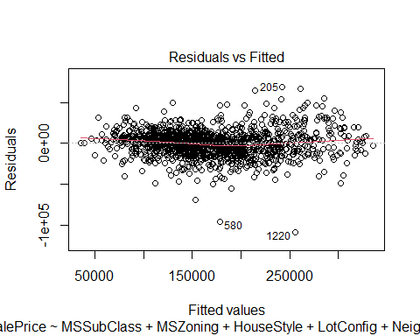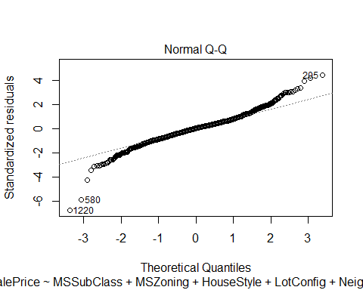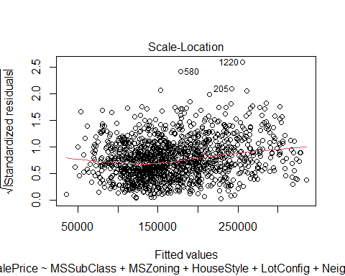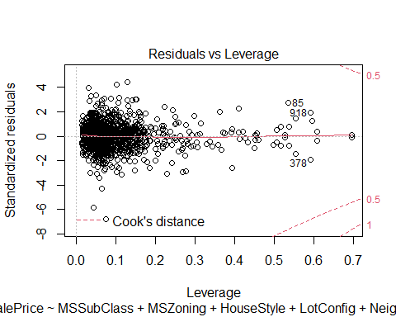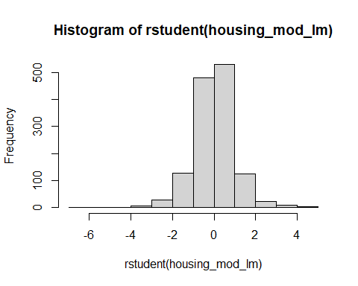

As we can see, fitted line on Residuals vs Fitted values, is close to 0 residuals line and as we go towards the lower and upper extremes, the line seems to deviate from ideal fitted line. It can be improved with possibly more number of records for model creation and possibly reducing some of outliers on the lower and upper ends. Also in this plot, residuals in our model shows a fairly random pattern, which is indicative of situation in which the assumptions of linearity, randomness and homoscedasticity have been met.

Normal Q-Q plot shows most of the records fall between 2 standard deviations of the mean, mostly along the straight line fit and thus the model is a good representation of the data, for predictions.

Histogram of Studentized residuals also shows a close to normal distribution up to 2 standard deviations around mean, although we can confirm the same cases earlier that we might be having some level of outliers / skewness in the distribution which might be causing slight deviation of the residuals from the straight line.

Looking at the model, it is fairly close representation of the sample and a generalizable model to the larger population. It can be improved further by deleting outliers for model building purpose. We may need to consider additional predictor variables or more cleaning of data is needed. Another way, perhaps could be finding additional / larger size of data, which can smoothen out the normal distribution even further and help improve accuracy of the model. Current data size after filtering became 1344 records. So, possibly a little larger data size could help.

## References

Field, A., J. Miles, and Z. Field. 2012. *Discovering Statistics Using R*. SAGE Publications. <https://books.google.com/books?id=wd2K2zC3swIC>.